Tab 1
MISSION:
Make growth accessible for great roofing companies, starting with perfecting our customer service to ALL of our wonderful clients. Clear, concise, correct and complete communication + delivery of results are at the forefront of our minds.

PREFACE
After completing the onboarding and service delivery SOPs for a client, you should focus on communications(check-ins) and ongoing management(to ensure the client is content with lead volume/quality).

Communication

Client Check-ins
- Create a row for the client’s information(Name/Service Area/Launch Date)Client Check-In System
- Use messaging/script templates for client check-ins
RoofIgnite – Client Check-In System SOP
- Update spreadsheet to note down check-ins

Communication Necessities
- Announce early wins and positive results we get for our clients publicly with our client to celebrate the win to excite them. (This is part of the R for reinforcing the prospect’s decision- in the CLOSER sales framework)
  - For example, if we launch a new client on $150 a day and they get 3 leads that come in and 2 confirm in the first 24 hours, we would send a message on Slack notifying them that this is great news and more leads are on the way, etc.
- Call clients if they text us CODE-RED, EMERGENCY level messages such as wanting to cancel or being frustrated. Acknowledge their problems and listen first but be proactive in taking accountability if we fell short on our delivery. Propose a gameplan.
  - Notify Oscar, Jon - Cole + Tyler (working together, communicate this).
- If a client is severely underperforming under KPIs in the first 5 days of launch or in any 7 day window of time (Refer to Actionable Steps)
  - Notify Oscar, Jon - Cole + Tyler (working together, communicate this).

General Communication
- If a client messages us about something important as it pertains to our ads/back-end system, we want to ensure we respond in under one hour.
  - Example: Hey, I’m noticing leads are slowing down. Is there something you need to do???
- If a client calls and you are spread thin on time, you can text them and let them know that you can call them in X hours or the next day, as an example, but can text if they just let us know what’s going on so we can help.

Service Delivery KPIS

RoofIgnite KPIS… the tell-tale signs of a decent-great performing client account. This includes both ad account and call center level metrics.

Full Disclosure:
- Client results are REALLY dependent upon how established the brand of the company is.
- Client results are also dependent upon the market they are launched in. One client launched in Miami Florida will get drastically different results compared to a client in Houston, TX, all other things being equal.

DEFCON 1 Clients to WATCH OUT for:
- Clients who don’t have roofing in their business name
- Clients who run call centers to get leads
- Clients who don’t have Google My Business Profiles/under 15 Google reviews
- Clients who are new to business and are transitioning from another contracting niche (general construction) to specializing in roofing
- Clients who are located in one area and want to get leads in another (Founders Roofing is the perfect example. 6 locations in 6 different states, only has 1 Google My Business setup for Frisco, TX but wants leads in Akron, OH). The lack of local creatives/GMB/FB page with local resonating things like phone numbers/local looking homes hinders performance
- Let the client know that historically, the most successful clients have shared the qualities of possessing X, Y & Z and to maximize their lead flow for the investment they are making, all they need to do is get local images/setup a Google my business profile to appear more established.
- Notify Oscar of DEFCON 1 clients before they are launched

Ad-level KPIS:
- $20-$50 CPM
- $1-3 Link CPC
- 0.9-2% Link CTR
- 3.5-8% CTR (All)
- Frequency(KEEP BELOW 2.5 TO KEEP UP WITH AD FATIGUE)

Landing Page
- Lead Survey: 2-5% of total clicks turn into leads
- Request Appointment: 40-50% of total people who opt-in request appts themselves

Bird’s Eye View KPIS (4 week timeframes):
$100/day
- 20-25 lead opt-ins
- 12-15 confirmed, scheduled appointments
- $200-250/confirmed appointment
$150/day
- 25-35 lead opt-ins
- 20 confirmed, scheduled appointments
- $225-250/confirmed appointment
$200/day
- 35-50 lead opt-ins
- 25-30 confirmed, scheduled appointments
- $225-250/confirmed appointment
$335/day
- 55-75 lead opt-ins
- 35-45 confirmed, scheduled appointments
- $250-300/confirmed appointment

Call center pick up rates: 40-50% is good

Struggling Subaccounts Actionable Fixes
- There is a great saying by a $20M+ individual sales rep, Jeremy Miner, that goes: Objection prevention is better than objection handling.
- This holds plenty of truths, and we should be proactive and always communicate with our clients about (deficiencies in results/delays in promises) before they contact us.
  - But maintaining a 100% ratio of keeping on top of dozens of clients without issues arising is not entirely realistic. This section addresses how to handle lead slow-downs/drop in lead appointment quality from client feedback:

Issue identification process:
How To Get Consistent Results From Paid Ads Every Single Month
These are the issues and steps to address them from top-of-funnel moving further down the sales cycle:
- Client lead flow slows down for a given 7 day time period (total KPI for 4 weeks divided by 4):
- This is a TOP of FUNNEL ISSUE, meaning the issue is that not enough leads are coming in.
- Check ad level KPIs and see if the issue is there. If it is, it is likely an issue with the ad creative, fix accordingly to lower CPCs/Link CTRs/CPM, etc.
- If ads are not the issue, check 1st stage of LP KPIs. Is this a lower-trust market or a DEFCON 1 client? If low LP opt-in is the issue, we need to fix the 1st stage LP.
  - Try switching the order in which we ask questions from 7 questions to 4 questions and notifying our calling team to use the special questions
  - Check Klaus Roofing of Texas Hill Country Subaccount to see the SURVEY/LANDING PAGE/FORM ATTACHED TO CALENDAR/AUTOMATIONS and adjust accordingly (ask me if you need some guidance I have done this many times so I can help you)
  - If you suspect it is an issue with the headline or psychological disconnect from ad to landing page, try adjusting headlines.

- Usually easy fix to tell FB to restart who it is finding to target as an audience: duplicate campaign and publish new one while turning off old one. Ask me if you want to confirm

- Leads are coming in out of service area!
- Refer to Loom below I show how to address this too.
- Leads are low-intent, low-pickup, low-urgency, mostly price-shopping overall unqualified!
- Leads isn’t the issue, we are getting volume but we notice quality is sub-par! So, we need to add pixel seasoning:
- PIXEL SEASONING - Only use this fix if lead volume is great. If we don’t send ENOUGH conversion events back to FB because we are literally withholding data, this fix can actually work against us. Usually this fix doesn’t do anything immediately but the quality starts to improve dramatically after 2-3 days. Monitor accordingly.
- Call pick-up rates are below 50%
- Issue: lower trust market.
- Is the number we are calling from apparent on the stage #3 - THANK-YOU PAGE?
- Are our VAs sending this message before calling? If not, make sure our VA Manager knows that they are falling short and the best course of action is to send this message right before calling
  - Hey William, it’s Jerica, saw you just filled out one of our forms, would love to chat about your roofing needs if you are open in the next 5 minutes, if not I have some time later today, let me know if that works, or we can also chat here over text if that’s more convenient.
- Are our VAs calling in under 5 minutes during business hours? Check some leads and see how soon they are contacted. If it is alarming, contact our VA manager!
If everything is good up till this point, we can try these technical fixes:
- Call the client and ask them if the phone says likely spam/fraud. Apply for CNAM/SHAKEN STIR on Settings > Phone Numbers > Trust Center
- Is it a good area code that matches what the locals use? If not, buy another phone number

TRAINING LIBRARY
CLIENT FIXES HANDS ON TRAINING LIBRARY

Client who has good lead volume but high % of leads are out of service area, not responding or cancel: Klaus Roofing of Oregon
https://www.loom.com/share/0d99edc169cf4f96b0bad51197c0550

Client who newly launched and has good ad-level metrics but low lead volume(sounds like a trust/survey friction issue): PointView Roofing
https://www.loom.com/share/99392ecd5e904ce89e681c6dab0e289d

Similar case to above with great ad-level metrics but low landing page conversion rate but full-send where we need to switch up ad copy too: Grandmark Service Company
https://www.loom.com/share/86695f85fc8c4941be147fb50f4d5bcf
Ad metrics are not within KPI so you are not getting good enough lead volume, but pick up rates are good and we are converting a good % of leads to appointments: Archetype Roofing
https://www.loom.com/share/bbfd2a9801914e04981b8b9da71cb174
Client lead flow slows down for a given 7 day time period: AllCraft Roofers
https://www.loom.com/share/d2f632ee7e694d66bfc63e4a7fc74d36

Client has lead flow slow down but it isn’t too extreme. This is more of an ACCOUNT HAS BEEN RUNNING FOR 2-3 months and we might need to swap out some fatigued creatives but don’t need to duplicate campaign. BONUS - 🔥 this video is a GEM for ongoing management so you can literally use the data you collect from which leads came from what ads to figure out how to model after what already works to turn off non-performing ads and turn on performers: Klaus Roofing Systems of Texas Hill Country
https://www.loom.com/share/ed65a4fdb81b4e03b2372daf00e949b8

Ad spend is limited to $50/day??? This is how to fix it. Also is that client’s business portfolio ineligible for business verification when you try to do that to increase the spending limit? If so, here’s the fix: AHI Roofing
https://www.loom.com/share/014abf82664e4a6fa99b82cdd029c33d

Delete existing CNAM record
https://www.loom.com/share/c7d3c23fafcf42b8b9cc08ba47c0ca21

Client who has issues with closing leads(unqualified + sales issue): MVW ROOFING
https://www.loom.com/share/5d43df0992ab429abe8fd875f7311dff

Client who appears to have consistent results for a few months, but then overall performance seems to decrease(lead flow drops, more out of service leads): Outstanding Roofing
https://www.loom.com/share/d3b59c5550074411bc23581300d7e158

Client that visibly gets MUCH less leads compared to historic months (ad fatigue/creative fatigue issue): Consumer Roofing
https://www.loom.com/share/0af9b8ac4770452ba54af5e2e65bfc5b

Client requests A/B test with running KNOW(STARTING AT PRICING ANGLE) versus MAIN(Story based angle with no numbers) to see if they get less price shoppers and more overall sales from the ads even if it means less overall leads. Smart business owner, Daniel Doran: Squatch Roofing

ISSUE was cost per schedule was around $200 for 2 weeks but then kept rising every day and never went back down after 2 more weeks and now it is at $400/schedule (on FB) - this doesn’t reflect leads who came in but didn’t perform the schedule event themselves, the actual cost per appointment might still be fine but still important to check.
https://www.loom.com/share/0d371ad8d363404b9e9e0dca8cc6397e

Situation where client NEEDS to have our Ad-to-Lead Qualfiication System built out on their GHL agency’s subaccount (Deal breaker otherwise they won’t work with us situation):
- Get Smart Construction is a different case than usual.
- We will be installing our Ad System inside their GHL and I have transferred all the assets over and also recorded a Loom of myself walking through the process on how to approach situations where the client has a dealbreaker on needing us to install our system on their GHL agency's sub account:
- If you ever encounter this, here's how to handle the client communications + GHL setup:
- https://www.loom.com/share/23404ec9af31419eb876682010fdd143

Connecting zapier so we create contacts under our client’s CRM (for example Roofr) automatically - Client: Madrids Roofing
https://www.loom.com/share/d5c9c9141e824acab01946cc0b3d8030

Full breakdown video on improving a client’s lead quality and volume for when you have other clients in the same area that are killing it but a client that is launched by you is slow and or lead quality is low. Client: Kover Solutions
https://www.loom.com/share/07dd1be8a96c4d60a936f30caf6cebcc

Ad fatigue killing lead flow - how to fix (Client is an HVAC contractor but the same ideologies apply to our roofing clients - Client: AQS Air Conditioning & Heating
https://www.loom.com/share/0f6689b9782f44959f6fde72c511d1fd

Switching over an account to an already A2P verified subaccount
https://www.loom.com/share/7f8322d24522419d885375cd7e2e2c1b

When you've been running a client's ads for 3-4 months or more, and spent a lot of money using the same ad copy (just swapping out creatives occasionally), here's what to do to deal with rising costs that literally won't go back to what it was once was historically. This client in question is called Klaus Roofing Systems of Texas Hill Country:
https://www.loom.com/share/a7ba3218ba094d5e9ca257330dfc4605

Connecting GHL to GOOGLE SHEETS to CLIENT’S CRM with ZAPIER so can AUTO-SYNC contacts under our client’s CRM (for example Acculynx) automatically - Client: Brown Roofing Company
Pt ½ https://www.loom.com/share/8a9d316d70f64f9d9b4ed95c3761ea3a
Pt 2/2 https://www.loom.com/share/095fe1fe2e7a4486a164d030a08ea80b
- IMPORTANT NOTE:
  - Sometimes you will switch the client some a 7-question survey to a 4-question survey. When this happens, you'll need to adjust the high-level automations, obviously, but then also the information that gets passed on the Google Sheet to Zapier. You'll have to go and fix the headings in Google Sheets to reflect the data that you changed, of course, and then as well as on Zapier, just clicking "Edit" and repopulating the field. Essentially, retesting it where it sends from Google Sheet and gets the most recent contact.
  - When you do that, you take that most recent contact which will have the data set up properly for the 4-question survey format information and then you go into each of the sections and fill in the info.
  - LETS SAY YOU DIDN’T SETUP THE ZAP. BUT NEED TO CHANGE THE 7 QUESTION SURVEY TO 4 QUESTION SURVEY. Ask the creator of the Zap in #service-delivery-discussion to share it with you so you can change it. Same with Google Sheets. If you don’t have access to the sheet with lead data, request access from the owner in #service-delivery-discussion

When client can’t provide creatives fast enough so you need to scramble to look at other clients’ creatives you can use in the meantime to mitigate ad fatigue:
https://chatgpt.com/share/68a9edf6-cd44-800b-ab68-475307545e6d

Advanced Pixel Conditioning LOOM FOLLOW ALONG (Client: Klaus Larsen Roofing)
https://www.loom.com/share/8625af65318a49aaa2ce69830df8f949

Client requesting sophisticated GHL stuff, live problem solving (client: US Shingle)
https://www.loom.com/share/9195143fae2b4eccbb9ad1cb64258879

SO MUCH OUT OF SERVICE AREA AND BY MARGINS OF HOURS
- fix with survey question - Client: Everlast ROofing
https://www.loom.com/share/3303b0f97948404fbb81b088acb31bcb

SE Roofing - Bad Appt Flow Problem Solving Orlando FL: Client: SE Roofing - Christian R - sales rep
https://www.loom.com/share/ae8eb877aa324dc5b6495d9778540118

Klaus Roofing of Cincinnati - weak lead flow and major OSA problem. Additionally, every time we attempt to solve for ad fatigue, CPC, LCT and CPM get worse! This is the creative development mastery process:
https://www.loom.com/share/ab849120a0bb44f4bfee5d5cb651bec4

SLOW BOOKING FLOW, BAD OSA - Citadel Problem Solving
https://www.loom.com/share/fecb4cd569bf4abf9e60673f3a6d2810

EZ Exteriors slow lead flow, good booking - Problem solving
https://www.loom.com/share/4a929ae9c19640fdb1fa6f3e688ebf56

Multiple service areas FB ad manager setup/phone routing setting/VA user assigned setup/automation setup/survey setup/team comms setup - client: Omega Exteriors Midwest/Florida Roofing & Gutters SWFL
https://www.loom.com/share/6faefc01e04c43198b38d7c648c969b6
- COMMON QUESTION: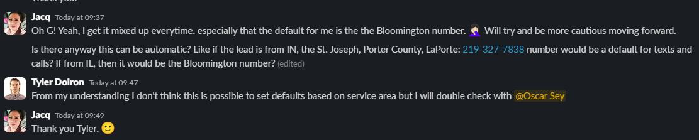
- Answer: @Tyler Doiron in this video I highlighted how I set the defaults based off of a lead that comes through the funnel. The purpose of the setup I performed here was to have it where a lead that came from a Bloomington ad would go to the Bloomington LP and fill out that specific survey(which would trigger one automation to assign one of our lovely VAs who had the Bloomington number assigned to them - so that it would send text from that number - vice versa with the other one) Does that make sense? Let me know.
- So I checked and it looks like this one Bloomington lead DID get a text from the Bloomington number but when Ann called, it showed that it called from the MAIN service area phone number. That's because @Louie Ann Z. is assigned to the Bloomington number.
- THis is a problem because pick up rates drop dramatically when the area code is not correct. For this account, the only way that it is "automatic" is if Jacq calls only Bloomington leads and if only @Aica B. were to call main service area leads (she's assigned)
- But that setup doesn't work anymore since we have multiple team members collaborating with different schedules. So, the best way I can think of organizing this is, to unfortunately check the TAG of the lead and see if it says Bloomington or MAIN Service Area, then call with the appropriate phone number from the dialer manually by copying and pasting their phone number. Please do some research to see if there is a way to automate this and provide the AI context @Tyler Doiron. That would be a game changer. For now, please take the actions I have outlined here for dialing.
- Looping you in on this @Leila @Jacq
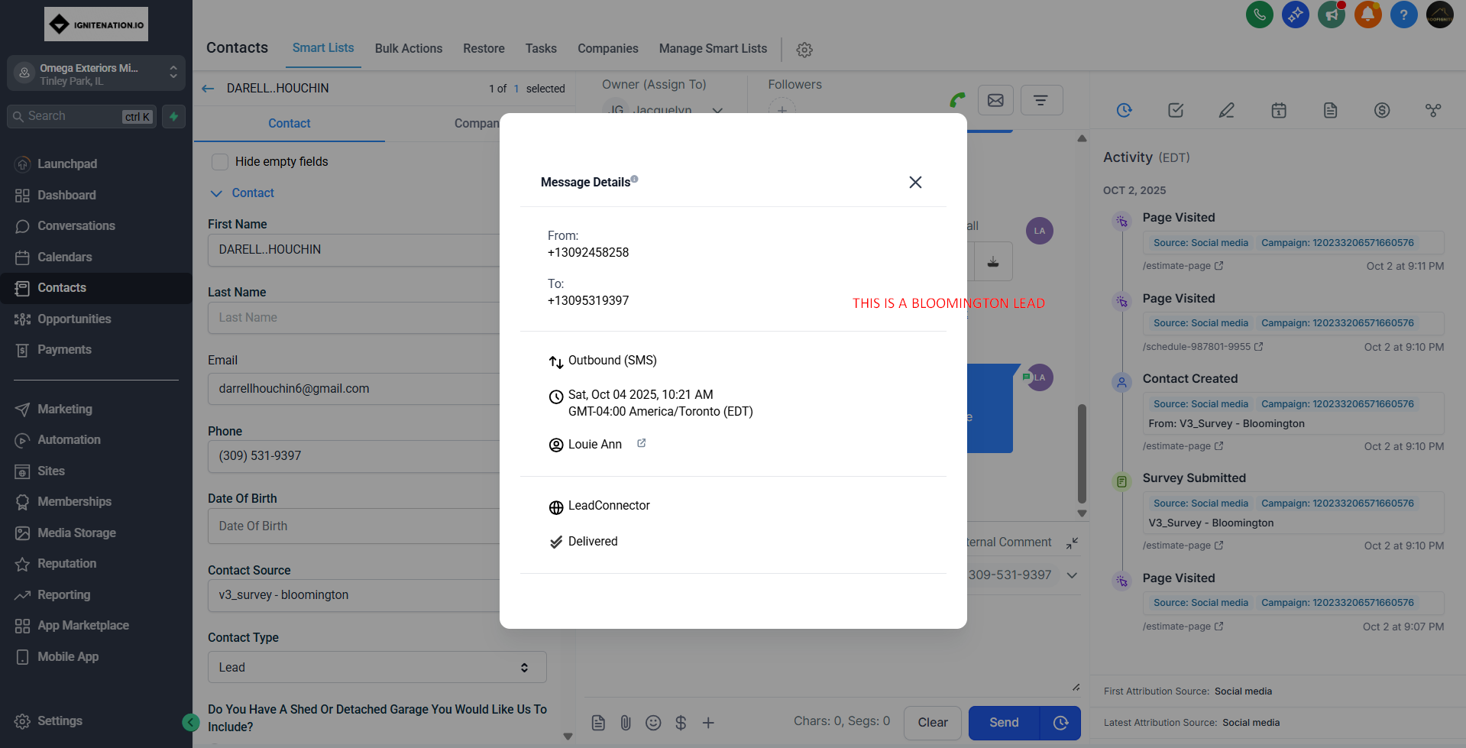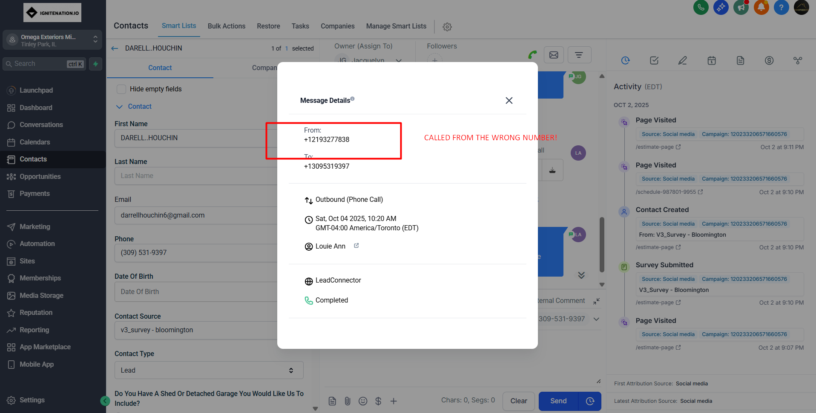
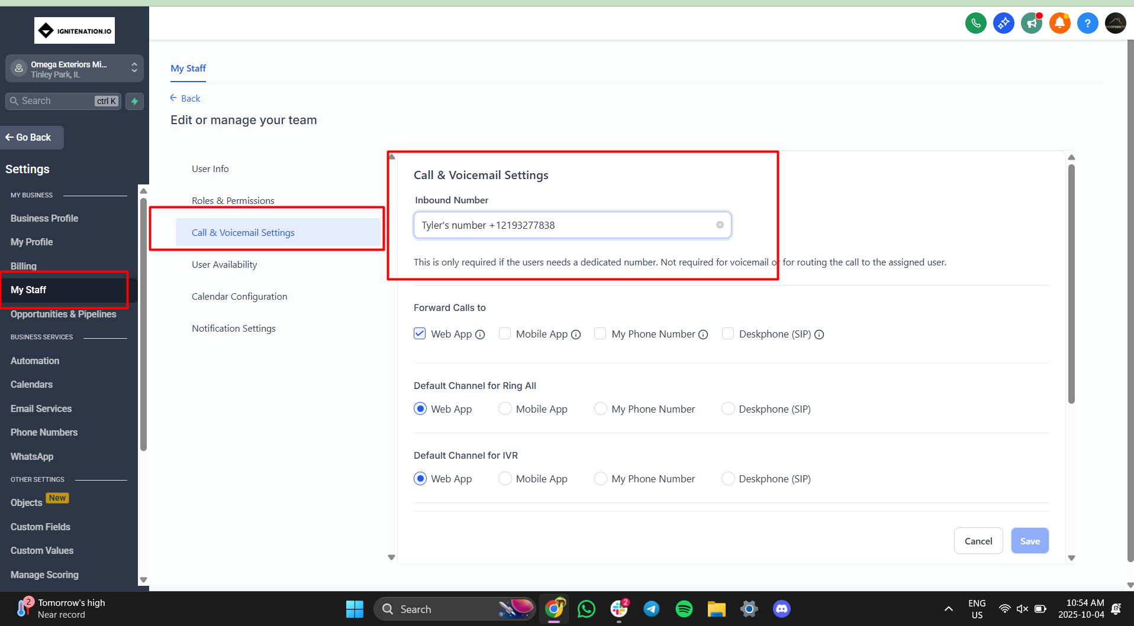

Extremely slow lead flow fix for longstanding accounts. Client: US Shingle
Full Creative Refresh w/ Psychological Triggers Training:
https://www.loom.com/share/d98186317ecd4df4bea4dbc448d4c738

Polishing creatives that were bound to be part of a creative refresh (Client: Florida Roofing and Gutters)

“I wanted to share a recent creative mastery video I put together for Randy consulting why a specific creative setup wasn't working as well + what I did to alter creatives and turn around results for the campaign so that Randy has a framework moving forward.
Here it is for you as well to watch so you can make the best creatives with even further improved intention!
It's about 15 minutes, tell me your main takeaways are after watching this”
https://www.loom.com/share/7c3289fb985940069a70fc24f13e9d7a
LONGSTANDING CLIENT hints at cancelling. How to handle recent poor performance when overall things are good (Client: Florida Roofing and Gutters/Freedom Roofing Group)
https://www.loom.com/share/92eb6eab8a77435db39906f944b9f2ad?sid=1d1d8b1d-4b8f-4088-8801-b5dd1d4129b3

LONGSTANDING HVAC client is having slower lead flow and we have done creative refreshes and it is still slow (Client AQS Air)
- We just shortened the survey

- I made this video on how the process looks like for shortening HVAC survey (since we're going into HVAC) - also did some other things inside here
  - https://www.loom.com/share/c0b8fbd567ae4370ae2bc50552367087

- Change had already been made so only action step from here is to:
- Inform VA team that we went from 7Q to 5Q survey and removed the following questions
  - Where in the planning process:
  - {{contact.where_are_you_in_the_planning_process}}
  - PAYMENT METHOD:
  - {{contact.payment_method}}
- Inform client what we did and why so they know we're on top of things

Following all the steps for a client in an area where our service delivery is proven but lead flow is too slow and cost per appointment is way too high? Or even infinite because you haven’t gotten any confirmed and it’s been more than 3 days? Yikes! The fixes are in the finer details though. Here’s me breaking it down
“I'm going to get hands on with the Modern Exterior account. Going to record a Loom while looking into it to keep you in the loop on what's adjusted @Randy Roseway and will circle back here when done:

All done

Loom video:
https://www.loom.com/share/95e955cdd3524c7dbaaeff5e385963f0

Biggest issues were with:
Leads not picking up phone (CNAM Should help solve + other phone for multiple angle penetration)
Ad copy maybe not strong enough
Lead flow $200/lead for the 6 we got

Action steps taken:
CNAM applied
Landing page headline changed (also applied logo change)
Creatives (took all the "better performers" put them into a new campaign (noticed last campaign had better metrics which was strange)
Switched copy to MAIN and KNOW V2
Bought a secondary phone number that VAs can call from should all call attempts from PRIMARY phone (Delaware based) be unsuccessful (since 80% of our zips are Greater Philly suburbs - bought a phone for that) - multi angle penetration
Changed callout from Greater Philly to Greater Philadelphia

TO DO:
Confirm if client good to run radius as a temporary crutch to boost lead flow
Will switch back afterward if issue, if not issue we can just continue that if it works
Update client on improvements - call check in would be ideal
See if we can switch to radius @Jonathan Forbes please confirm I haven't launched campaign yett”
Client has an underperforming account, lead flow is slow so you need to go and perform a creative refresh. CAVEAT IS CLIENT IS A BIG CLIENT and gives us everything we need. How to go about creative selection and reserve:
https://www.loom.com/share/edf082d9ab504c82a4cc735cc8479847

Client has ads that are underperforming but a few leads came in and you want to identify from which ad since it doesn’t say on the lead mastersheet (Ad attribution)
https://www.loom.com/share/3cdb39244caa459abe9c6df69f1f182c

BOTTLENECK ANALYSIS WHEN CLIENT IS STRUGGLING AND YOU NEED TO KNOW EXACTLY WHAT TO DO
https://www.loom.com/share/ea1387a557544bf0b91f7dcc808d7241?from_recorder=1&amp;focus_title=1

KPI BREAKDOWN AND WHAT HAPPENS TO COST PER APPT WHEN YOU SCALE AD SPEND?
https://www.loom.com/share/8bb0a7c60ae746ceabc75b27ed5a29d2

What does our VA team actually do? What is being mentioned on the calls that VAs make to homeowners on behalf of us and our clients?
https://www.loom.com/share/6b49fbcc1eb74345be7f7791e7e37355

